The American University in Cairo
Mechanical Engineering Department

MENG 356: Mechanical Design I

Problem Sheet 3

Enclosed are the characteristics, technical data and drawings of a gearbox. You will observe two different gearboxes in the lab. You are required to prepare a report that will include the following:
- Schematic diagram for the gearbox showing the different gear connections for the different gear ratios.
- Make a list of all parts involved in the power and load transmission for each gear ratio.
- Identify the kind of fit between the different elements.

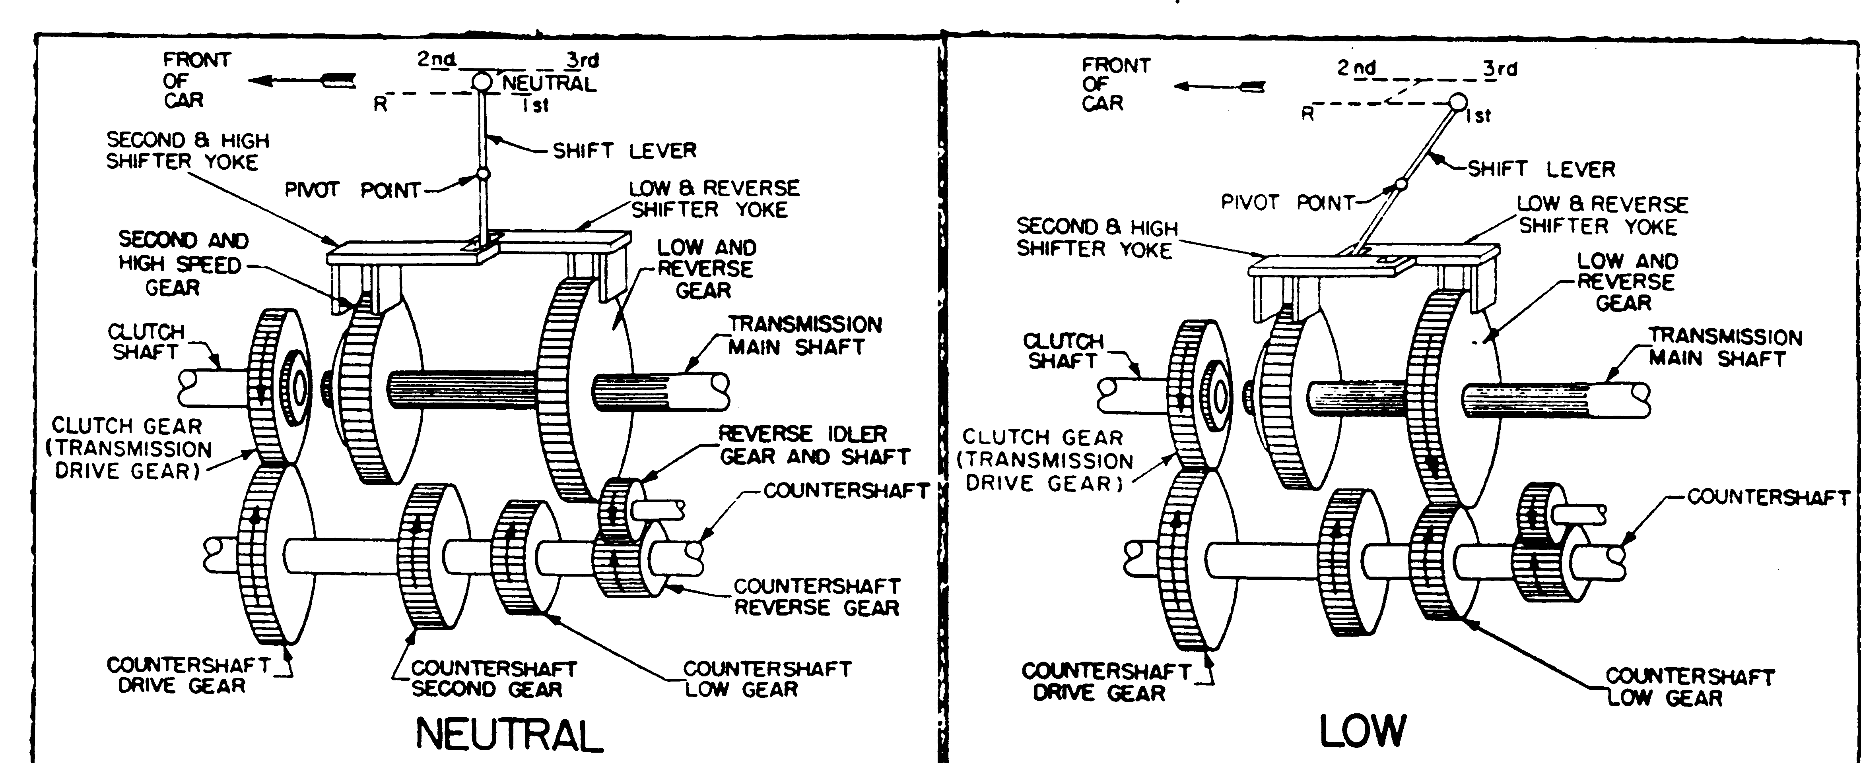
Fig. 1-14 Transmission with gears in neutral Fig. 1-15 Transmission with gears in low
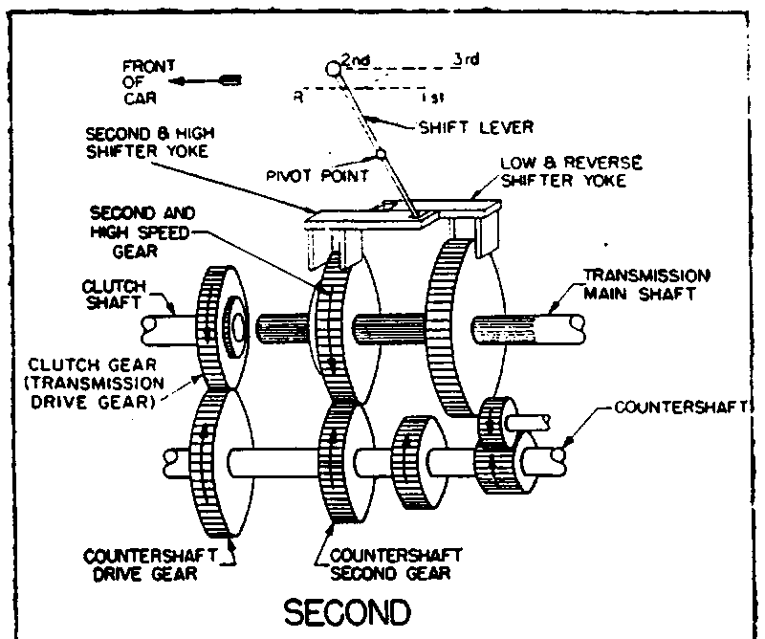
fig. 1-16. Transmission with gears in second.
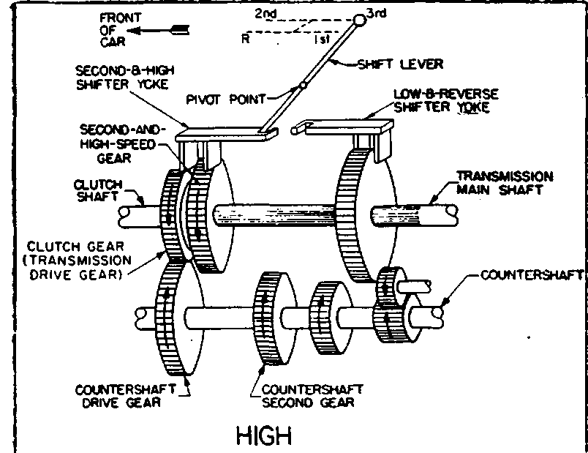
fig. 1-17. Transmission with gears in high.
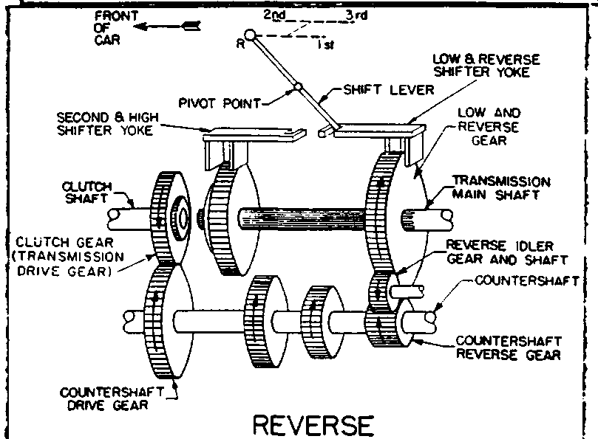
Fig. 1-18. Transmission with gears in reverse.

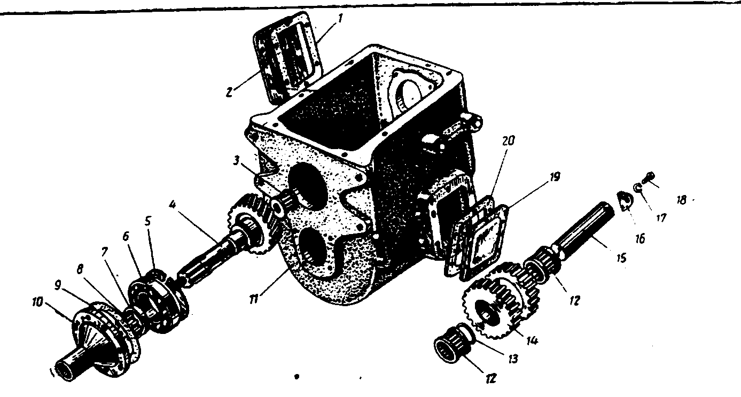
Fig 26. Transmission case, main shaft and reverse speed gear

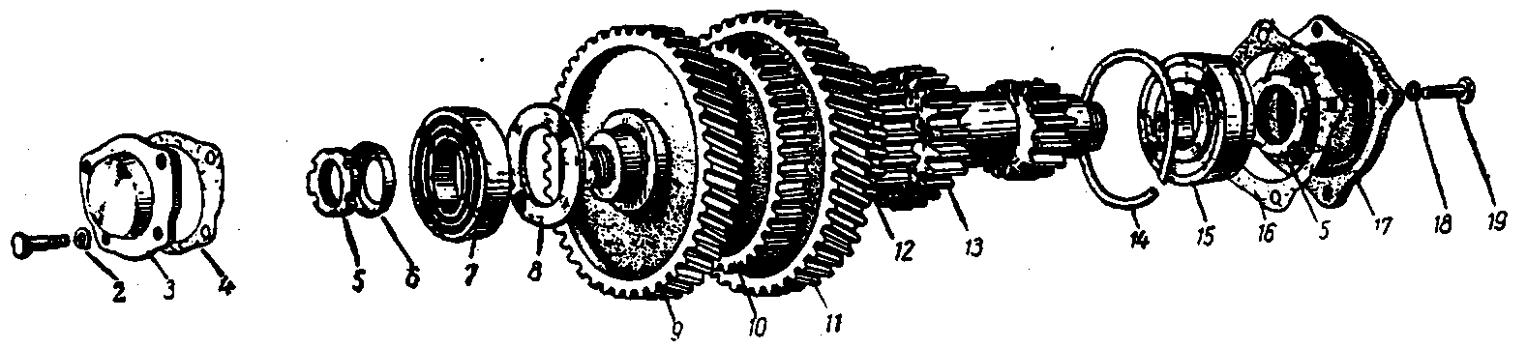

Fig 27. Transmission countershaft

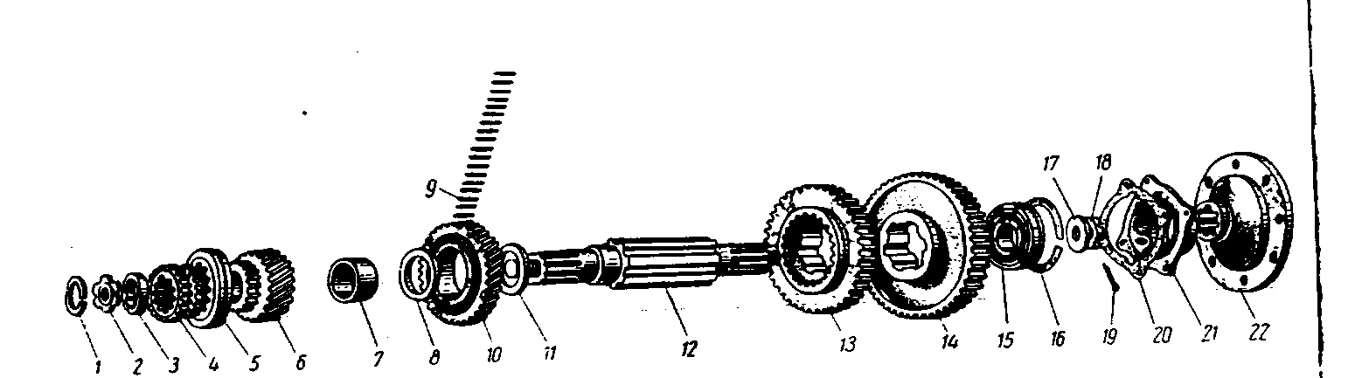
Fig 28. Transmission secondary shaft
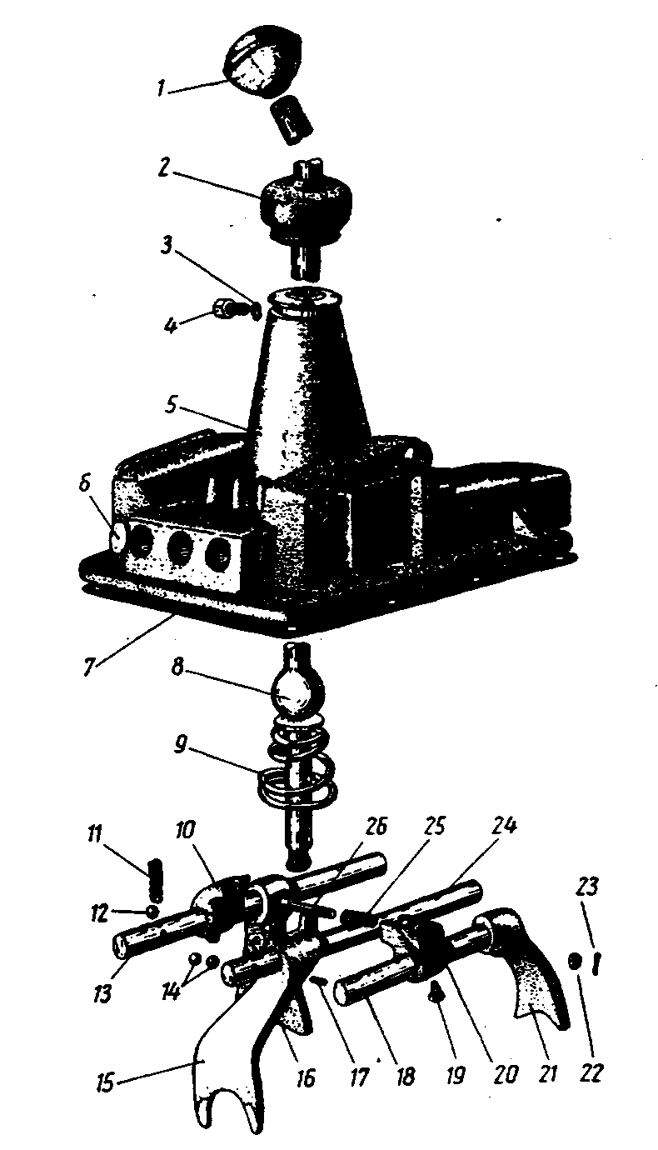
Fig. 29. Transmission case cover and gearshift arrangement

Figure No. | Position No. | Part Name
Group 17. TRANSMISSION
Subgroup 1700. Transmission Assembly

Transmission assembly

 |  | Subgroup 1701. Transmission
26 | 11 | Transmission case  Bolt, transmission case  Washer, spring
 | 2 | Cover, transmission case hand-hole
 | 1 | Gasket, transmission case hand-hole cover
 | 16 | Cover, transmission reverse gear hand-hole
 | 17 | Gasket, transmission gear hand-hole cover  Bolt, transmission case hand-hole cover  Washer, spring  Plug, transmission case, taper
 | 4 | Transmission main shaft
 | 6 | Bearing, main shaft
 | 5 | Ring, main shaft retainer bearing
 | 8 | Nut, main shaft bearing
 | 7 | Ring, locking
 | 10 | Cover, main shaft bearing
 | 9 | Gasket, main shaft cover bearing  Bolt, main shaft cover bearing  Wire, cottering
 | 13 | Bearing, main shaft, front
27 | 13 | Countershaft, transmission
 | 12 | Gear, countershaft 3rd speed  Key, countershaft 3rd speed gear
 | 11 | Gear, countershaft 5th speed  Key, countershaft 5th speed gear
 | 9 | Gear, countershaft constant mesh  Key, countershaft constant mesh gear
 | 10 | Gear, power take-off gearbox, driving  Key, power take-off gear box, driving  Bushing, transmission countershaft, spacer
 | 8 | Washer, transmission countershaft, thrust
 | 7 | Bearing, transmission countershaft, front
 | 5 | Nut, countershaft front bearing thrust
 | 6 | Cap, locking
 | 3 | Cover, countershaft front bearing
 | 4 | Gasket, countershaft front bearing cover
 | 1 | Bolt, countershaft front bearing cover
 | 2 | Washer, spring
 | 15 | Bearing, transmission countershaft, rear
 | 14 | Ring, countershaft rear bearing
 | 5 | Nut, countershaft rear bearing, thrust  Washer, locking
 | 17 | Cover, countershaft rear bearing
 | 16 | Gasket, countershaft rear bearing cover
 | 19 | Bolt, countershaft rear bearing cover
 | 18 | Washer, spring
26 | 14 | Gear, reverse speed
 | 12 | Bearing, reverse speed gear
 | 15 | Shaft, reverse speed gear
 | 13 | Ring, bearing, spacer
 | 18 | Stop, reverse speed gear
 | 20 | Bolt, reverse speed gear stop
 | 19 | Washer, spring
28 | 12 | Shaft, transmission, secondary
 | 14 | Gear, 1st speed
 | 13 | Gear, 2nd speed
 | 11 | Washer, thrust
 | 10 | Gear, 3rd speed
 | 9 | Needle, bearing  Gear, 5th speed complete with spacer bushing
 | 6 | Gear assembly, 5th speed
 | 7 | Spacer bushing and pin assembly
 | 8 | Washer, 5th speed gear, thrust
 | 4 | Cluster gear, 5th and 4th speed
28 | 5 | Clutch, 5th and 4th speed cluster gear
 | 2 | Nut, 5th and 4th speed cluster gear
 | 3 | Ring, locking
26 | 3 | Bearing, secondary shaft
28 | 1 | Thrust washer, secondary shaft bearing
 | 15 | Bearing, secondary shaft, rear
 | 16 | Ring, secondary shaft rear bearing, retainer
 | 21 | Cover, secondary shaft rear bearing
 | 20 | Gasket, secondary shaft rear bearing cover  Bolt, bearing cover, long  Bolt, bearing cover, short  Bolt, bearing cover, drilled head  Washer, spring
 | 22 | Flange, secondary shaft
 | 18 | Nut, secondary shaft flange
 | 17 | Washer
 | 19 | Cotter pin, secondary shaft flange nut
 |  | Sub group 1702. Gear Shift Mechanism
29 | 5 | Cover, transmission, upper
 | 6 | Plug, transmission cover, expansion  Plug, transmission cover, expansion
 | 7 | Gasket, transmission upper cover  Bolt, transmission cover, adjustment  Washer, spring  Bolt, transmission upper cover  Washer, spring
29,64 | 8,15 | Lever gearshift
 | 4 | Bolt, gearshift lever, adjustment
 | 3 | Washer, spring
 | 2 | Sheath, gearshift lever
 | 9 | Spring, gearshift lever
 | 1 | Knob assembly, gearshift lever
 | 11 | Spring transmission cover locking device
 | 12 | Ball, transmission cover locking device
 | 14 | Ball, gearshift rod lock
 | 15 | Rod. 4th and 5th speeds gearshift
 | 18 | Lock pin, 4th and 5th speeds gearshift rod
 | 16 | Fork, 4th and 5th speeds gearshift
 | 20 | Screw, set.  Cotter-wire, set screw
 | 13 | Rod, 2nd and 3rd speeds gearshift
 | 17 | Fork, 2nd and 3rd speeds gearshift
 | 20 | Screw, set
 | 10 | Block, 2nd and 3rd speeds gearshift
 | 20 | Screw, set  Cotter-wire, set screws
 | 19 | Rod, 1st and reverse speeds gearshift
 | 22 | Fork, 1st and reverse speeds gearshift
 | 20 | Screw, set
 | 21 | Block, 1st and reverse speeds gearshift
 | 20 | Screw, set  Cotter-wire, set screws
 | 26 | Guard pin, reverse speed engagement
 | 25 | Spring, guard pin
 | 23 | Nut, guard pin
 | 24 | Cotter pin

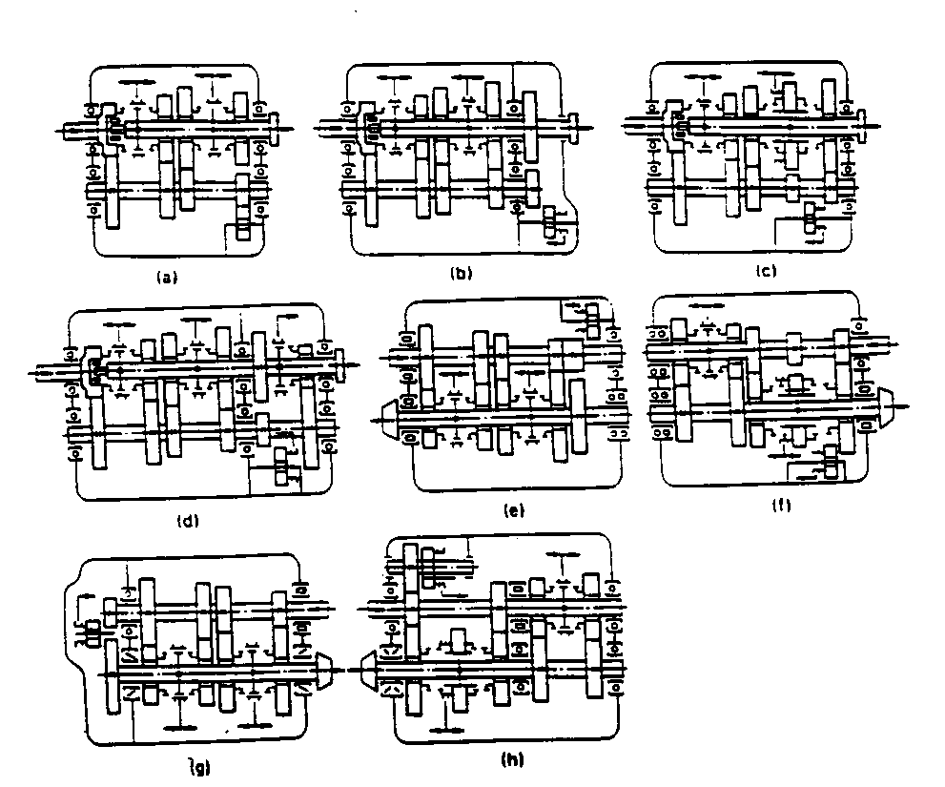

Fig. 48. Schematics of transmissions used in cars
(a) through (d) three-shaft; (e) through, (h) two-shaft
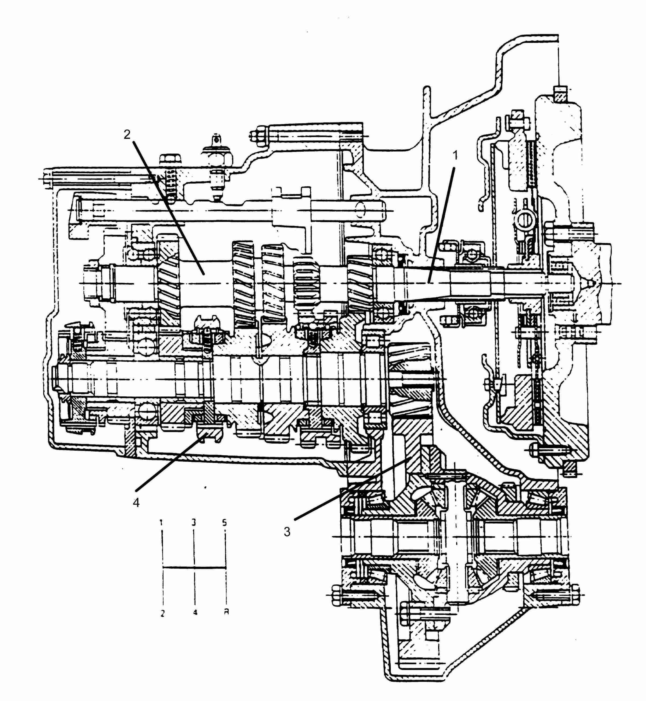

Fig. 47. Two-shaft transmission and main gearbox (engine mounted transversely)
1- Primary shaft, 2- Secondary shaft, 3- main gear, 4- synchronize

